Nandini Bavana  Bavana.Nandu@gmail.com  +971 56 155 3439 | 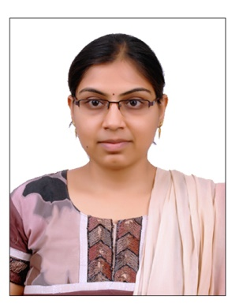

SUMMARY
A competent and organised individual who is able to work as part of a team and manage several priorities at any one time. Have a positive attitude, strong work ethic, and a keen desire to learn and grow within a firm and have extensive experience of working in commercially focussed organisations, and fully understands the pressures of achieving targets and accurately assessing job applicants according to their ability.
Right now he would like to work for a friendly and exciting company that is looking for an Assistant Pharmacist who can reflect their values of standards, excellence & quality.
EDUCATIONAL QUALIFICATIONS
Masters in Pharmacy, Pharmacology with First Class Distinction from S.R.M. University, Potheri, Tamil Nadu.
Bachelors in Pharmacy, with First Class from The Tami Nadu Dr. M.G.R. University, Chennai, Tamil Nadu.
TECHNICAL SKILLS
Expert in working with MS office (WORD, EXCEL and POWER POINT) and Internet applications.
PROFESSIONAL EXPERIENCE
Venkateshwara Medical Stores, Hyderabad, India
PHARMACIST - Oct 2012 to Jan 2016
Responsibilities include checking and dispensing medicines. Maintaining computer records, entering incoming, refill and prescription changes, counting and filing prescriptions after dispensing. Advise patients and their families regarding proper use of drug, storage.
RESPONSIBILITIES
- Accurately dispensing drugs to patients according to a doctor’s prescription.
- Checking prescriptions for errors & making sure they are appropriate for patients.
- Measuring, packaging, labelling and recording medications issued to patients.
- Instructing patients on how to use medications, possible side effects and storage.
- Contacting and working closely with other healthcare professionals.
- Answering questions from patients and staff about medicines.
- Ensuring the accuracy of all prescriptions, products and services supplied.
- Helping to develop the pharmacy's electronic discharge system.
- Managing and resolving complaints.
- Able to trains and supervise Pharmacy Assistants.
- Communicating with customers sympathetically and supportively.
- Giving private consultations when required.
- Maintaining pharmaceutical stock, creating inventories and ordering more drugs.
- Drug Inventory Management
Aizant Drug Research Solutions
CLINICAL PHARMACOLOGICAL TRAINEE - Jul 2011 to Apr 2012
To assist design drug trials, refer to data from the Human Genome Project and consult with scientists who have developed new pharmaceutical compounds and conducted preclinical testing. Coordinate testing of a drug's absorption, distribution, metabolism and excretion from the human body.
Detailed plans for phase one clinical trials involving volunteer patients. During the course of clinical trials, evaluation of a drug's effectiveness, monitor for side effects. Track other factors that influence a drug's effectiveness, including the presence of different drugs, food and dietary supplements.
RESPONSIBILITIES
- Assist in designing and carrying out experiments
- Devising and testing hypotheses
- Assist in testing drugs on cells or through clinical trials on humans
- Making recommendations based on findings from research and experiments
- Laboratory and staff management
- Studying relevant literature
- Writing reports and papers
- Collaborating with and sharing expertise and research findings with associated staff
- Attending meetings and conferences
PERSONAL PROFILE
Name | : | Nandini Bavana
Date of birth | : | 06-Nov-1987
Gender | : | Female
Visa | : | Spouse Visa
Nationality | : | Indian

DATE: SIGNATURE

